User manual

Tween Animation Function
DOFloat,
DOVector2D，DOVector3D，DOVector4D,DOColor,DOFade,DOMove,DORotation,DOScale,DOSize...
They are all similar functions, and a screenshot of the blueprint is shown below
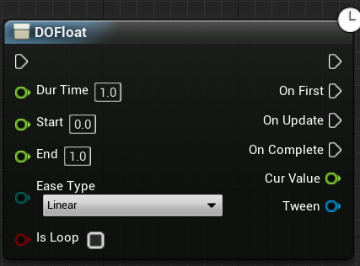
DurTime:The length of time the animation is executed
Start:initial value
End:End value or target value
EaseType:Type of tween animation curve
IsLoop: true it keeps going in a loop,false will run once
OnFirst:Callback for first frame change
OnUpdate:Callback for each frame change
OnComplete:Callback when end
Tween:Tween animation object

DoPath
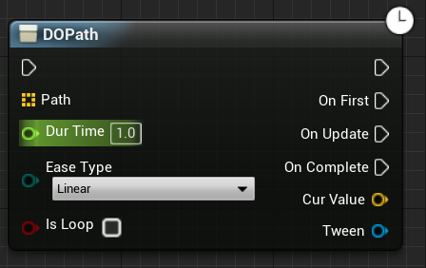
Path:Continuous waypoints

EasyType
In blueprint:
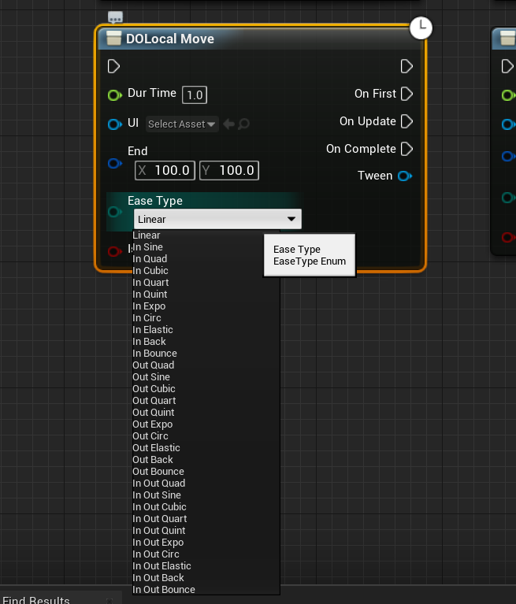
In C++ Code:
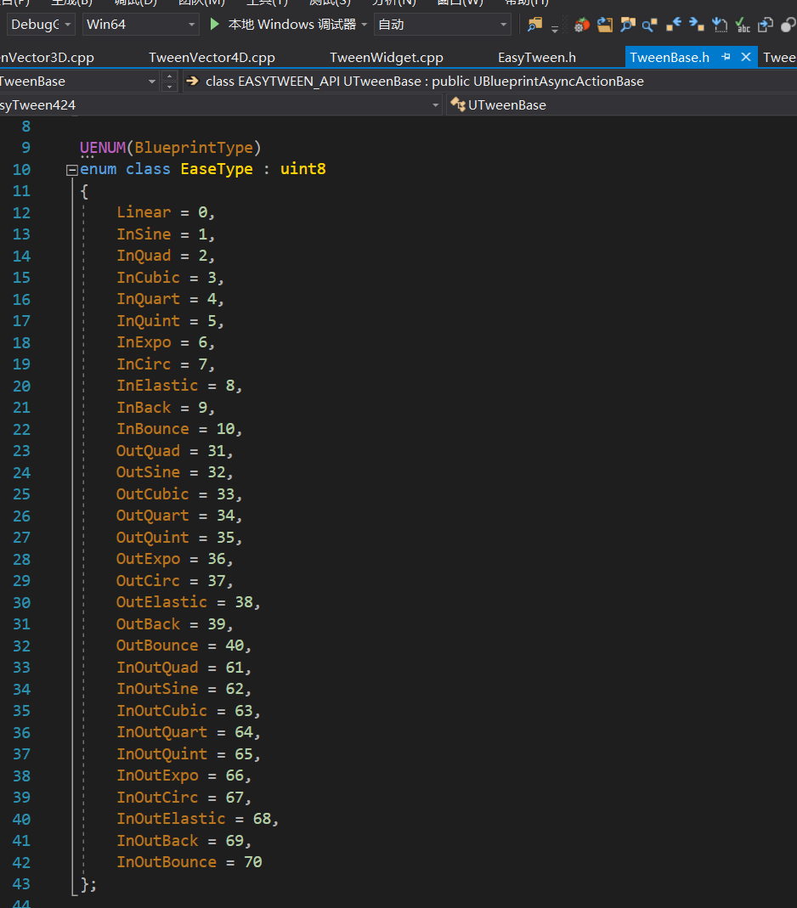
Animation effect：
